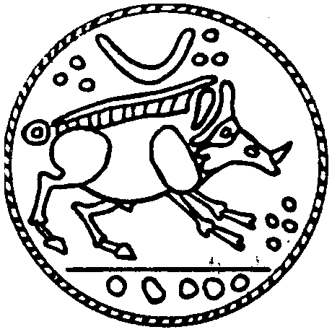

Middle Nene Archaeological Group

FOUNDED 1970

Are you interested in local archaeology?
Would you like to hear expert speakers?
Do you enjoy visits to ancient sites?
Would you like to try practical excavation & fieldwork?
Why not join your local Archaeological Group?
Annual subscription: Individual £10.00: Family £15.00
Further details from Andrew Brewster Tel: 01733 771075
Website: https://www.midnag.org.uk

Middle Nene Archaeological Group

Membership Application 2022-2023

(1 September 2022 – 31 August 2023)

Subscriptions: Individual membership £10.00; Family membership £15.00
I/we apply for individual/family membership of the Middle Nene Archaeological Group for the year 2022-2023.
I enclose the subscription fee of £10.00/£15.00 (individual £10.00, family £15.00)
Name: ……………………………………...........……………………………………………...
Address: ……………………………………………………….……………………………….
……………………………………………………………………………………….………….
Tel: .………………………………………………………………………………………..……
Email: ...……………………..…………………………………………………………..….…..
Your email address will help to reduce our postage costs
Signed: ……………………………………………..… Date: …………………………...
Please make cheques payable to Middle Nene Archaeological Group and send to:
The Treasurer, 26 Ringwood, South Bretton, Peterborough, PE3 9SH

